Brief story World Drug Day Activities 26th June 2021
Commemoration of International Day against Drug Abuse and illicit trafficking
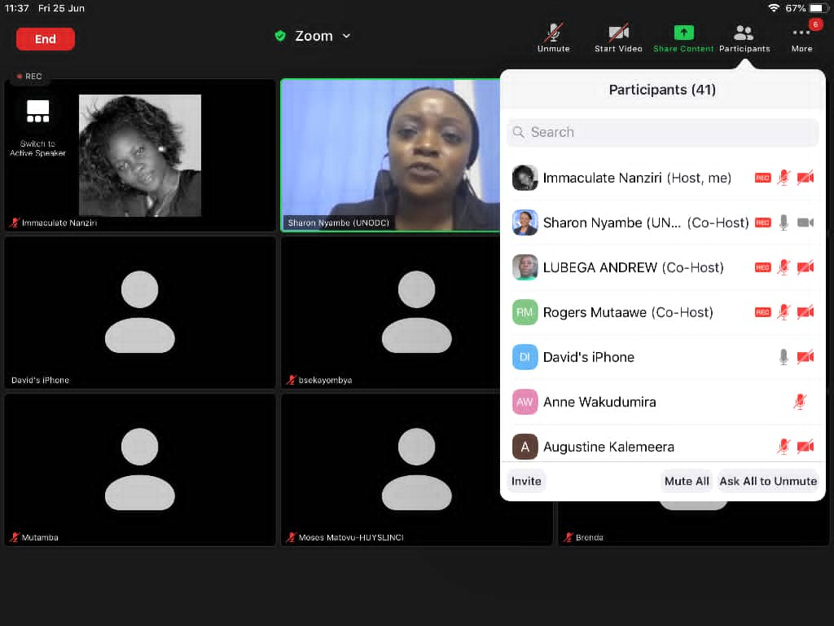
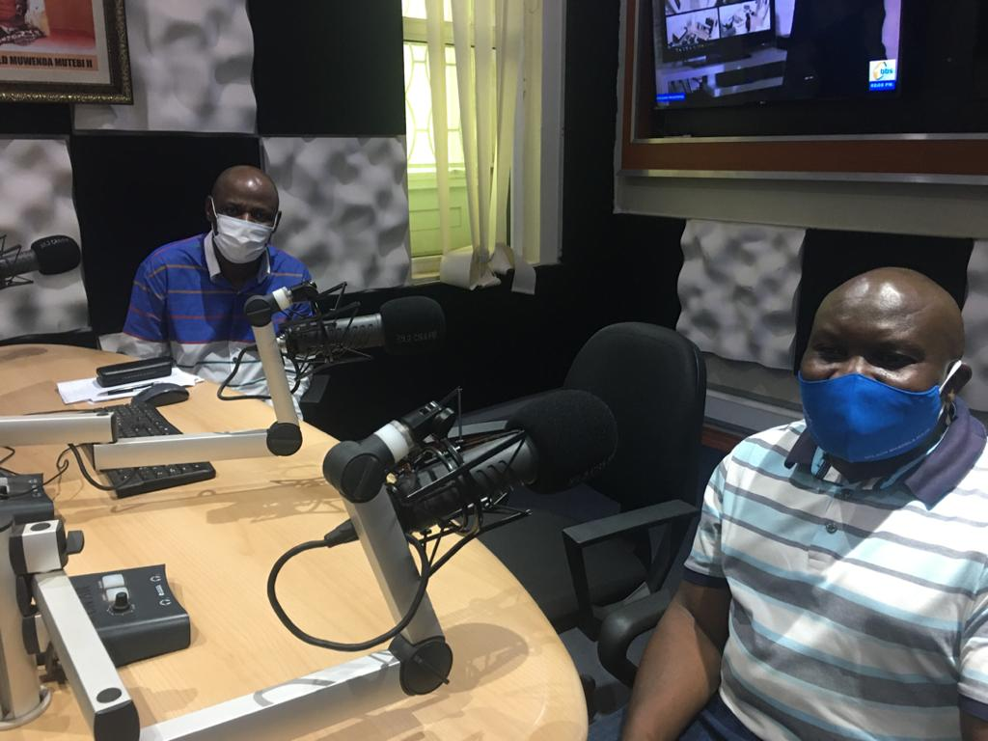
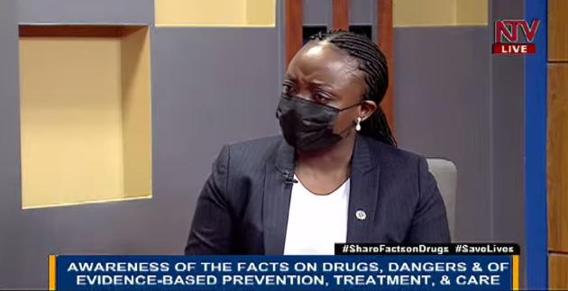
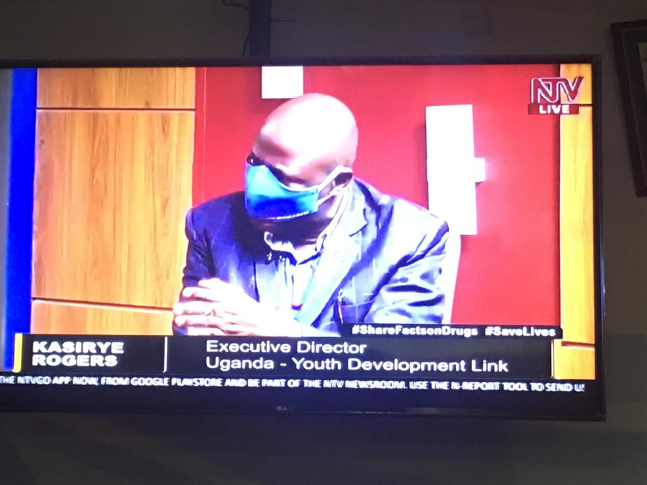

Report by: Uganda Youth Development Link (UYDEL)

Preamble
The International Day against Drug Abuse and Illicit Trafficking, also known as 'World Drug Day', is celebrated annually on 26 June. The theme of World Drug Day 2021 was "Share Facts on Drugs, Save Lives." The day as an event is celebrated worldwide with much conscious fervor to make people aware and emphasize the hazards of drug addiction and illegal trafficking. This year UNODC Uganda partnered with UYDEL and the Ministry of Education and Sports to commemorate the day. On this day we had two activities conducted:
- Online Stakeholder engagement held on 25th June 2021
The meeting was organized inform of an online webinar (zoom) and was moderated by Dr. David Basangwa were over 50 people participated. The participants were from Government Institutions, civil society and community based organizations. The panelists were Ms. Sharon Nyambe (Head of office United Nations Office on Drugs and Crime UNODC, Uganda Office), Mr. Kasirye Rogers (Executive Director Uganda Youth Development Link), Mr. Tinka Zarugaba (Commissioner of Police and Anti-Narcotics Department) and Dr Byamah. B. Mutamba (Senior Consultant Psychiatrist, Head Alcohol and Drug Unit, Butabika National Mental Hospital).
Key talking points
- To have a sustainable solution for the youth to divert them away from drug use
- Need to fight misinformation and boost research on illegal drug use
- The problem requires a lot of regulations
- Importance of raising awareness
- Drug use results into health problems, both mental and physical
- The use of illegal drugs among young people is going up. For example, 4 out of 10 young people admit to having used illegal substances
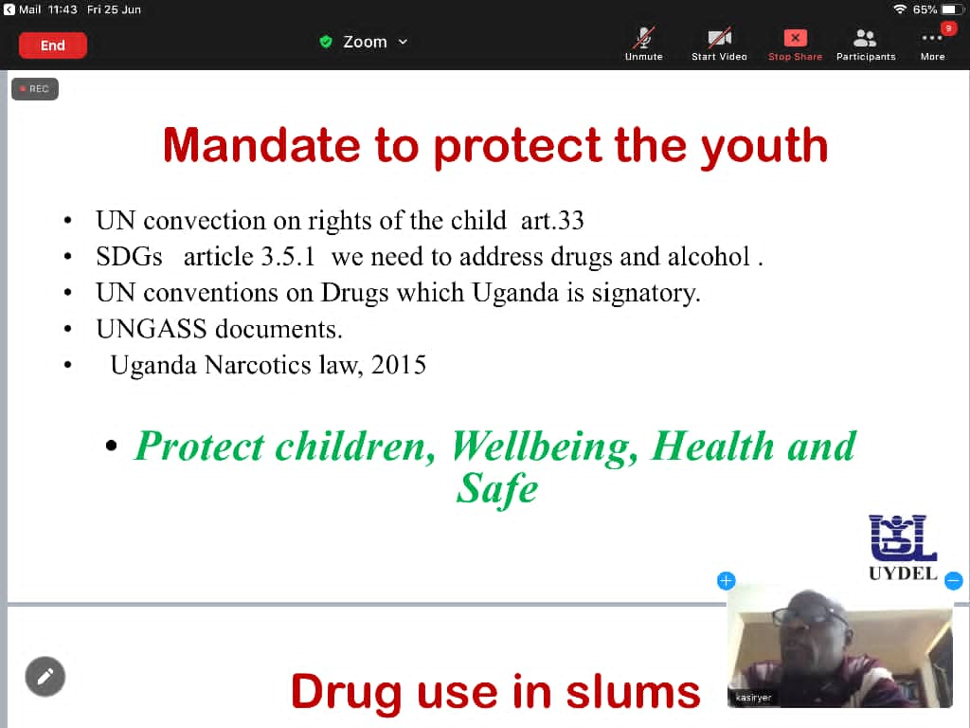
- Use of both preventive and treatment measures are necessary to address the drug abuse problem.
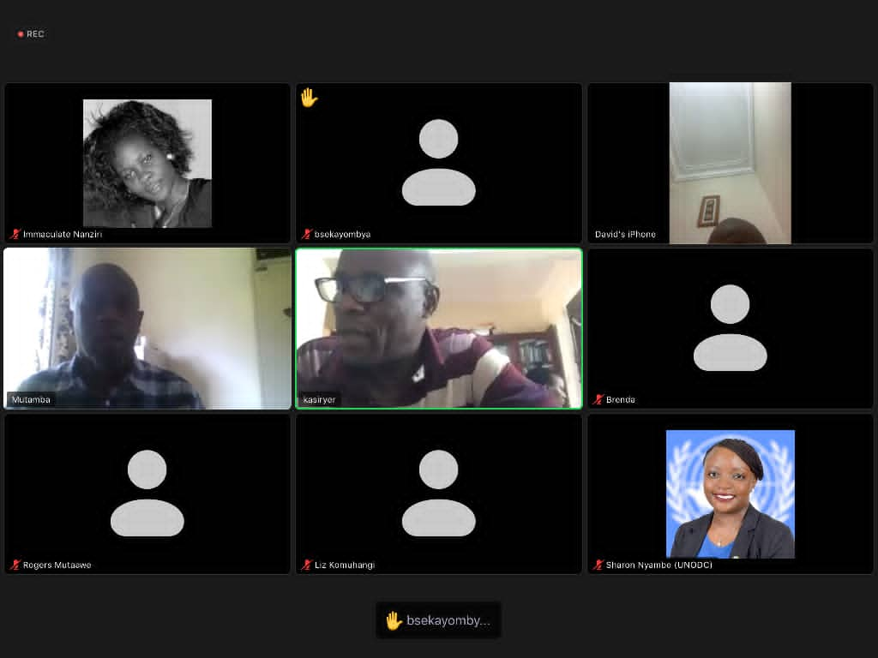
Some of the screen shots taken during the stakeholder online engagement
- Media engagements held on 26th June 2021
Live talk show on KFM 9:00am-11:00am: The panellists on KFM were Dr Byamah. B. Mutamba (Senior Consultant Psychiatrist, Head Alcohol and Drug Unit, Butabika National Mental Hospital) and Mr. Tinka Zarugaba (Ag. Commissioner of Police and Anti-Narcotics Department). The key issues under discussion were about Drug abuse prevention and treatment and also regulation at National level.
CBS FM 2:00pm-3:00pm: The panellists on CBS FM were Mr. Kasirye Rogers (Executive Director UYDEL) and Mr. Mutaawe Rogers (Senior Programs Manager UYDEL) and Ms. Kabakwenuzi Alice (Senior Nursing officer, In charge Alcohol and Drug Unit, Butabika National Mental Hospital who participated in the radio by phone in call. The key issues under discussion were about drug abuse prevention, referral to services and treatment options.
Questions and responses on both radio talk shows
Caller: There is increased use of concoctions due to COVID-19 and Marijuana is largely used. Is it right?
Response from studio: No, because it not prescribed by the doctors and frequent use of Marijuana results into addiction. Besides there are no studies that have shown any relationship with marijuana and Covid 19 treatment.
Caller: Are services offered at Butabika hospital for pay?
Response from studio: No, they are for free and a certain fee is charged for private cases.
Caller: Is Butabika hospital for only mad people?
Response from Studio: Not everyone that is admitted to Butabika is mad. People have got mental health problems. The nurse at the alcohol and drug unit said that they even admit patients at the alcohol and drug unit for a certain period of time.
Question: How does Uganda come to celebrate this day?
Response: Uganda comes in because it’s a signatory to several United Nations Conventions thus being part of the UN activities.

NTV talk show held from 4:00pm-5:00pm
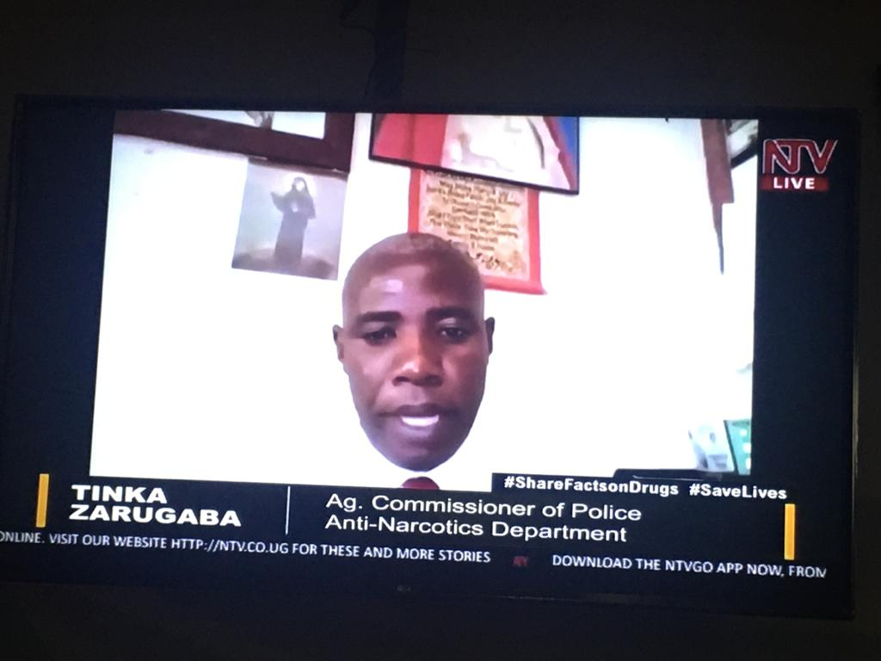
L-R Ms. Sharon Nyambe and Mr. Tinka Zarugaba during the NTV talk show
The live talk show on NTV was organized under the topic “The importance of awareness of the facts on Drugs (and their dangers), and of evidence-based prevention, treatment and care”. The panellists were Ms. Sharon Nyambe (Head of office United Nations Office on Drugs and Crime UNODC, Uganda Office), Mr. Kasirye Rogers (Executive Director Uganda Youth Development Link) and Mr. Tinka Zarugaba (Commissioner of Police and Anti-Narcotics Department) who attended online.
The key talking points were:
- The potency of cannabis has increased overtime.
- Drug abuse is on the increase especially among the young people and stakeholders need to conduct some interventions to address the problem.
- People look at drug abuse as a moral issue and not as a health issue hence seeking services very late from the recognised health specialists.
- There are some new plants on the market that enlist the same effects as conventional drugs. For example, kayongo which is grown in Busia.
- The use of smokeless tobacco such as kuber and shisa is a gateway to use of hard drugs.
- There are no early interventions for drug use problems and the lack of community component of care makes recovery difficult.
Outcomes
- Increased stakeholder engagements through use of technology given the current circumstances.
- Strengthened partnerships with stakeholders such as government Institutions, media and civil society organizations to create awareness about drug abuse prevention, care, recovery and treatment.
Challenges
- We experienced some internet connection difficulties to one of the panelist who attended the NTV talk show online. However, the connection eventually worked out.
- Limited physical engagement which led to postponement of activities such as the press briefing and youth festivals which could have contributed a lot to the awareness campaigns.
Recommendations
- Undertake follow up media engagements on television and radio through talk shows and jingles. The media houses can also be consulted to seek their views on how best to engage with the public while at the same time creating the needed awareness about substance use prevention.
- Conduct physical media (press briefing) after the lock down is lifted. This will help to disseminate the messages further and hopefully this also create media debates/discussions on major stations in Uganda.
- Disseminate the IEC materials (posters, t-shirts, and fliers) to stakeholders to support awareness creation efforts.

